ADITYA UNIVERSITY
Surampalem
Department of Artificial Intelligence and Machine Learning
DBMS CAPSTONE PROJECT
Project Documentation Report
Project Title: UNIVERSITY ACADEMIC MANEGEMENT SYSTEM
Submitted by:
S.No | Student Name | Roll Number
1. | KOSANAM BALA ADITYA | 25B11AI581
2. | MUDAY MOHITH NAIK | 25B11AI765
3. | GOPIREDDY DILEEP | 25B11AI361
Course: Database Management Systems (DBMS) Course Code: ____________
Faculty Coordinator: Mr. T. Srinivasulu M.Tech,(Ph.D.)
Academic Year: 2026-27 Date of Submission: __________
GitHub Repository Link: https://github.com/mohithnaik112-ctrl/university-academic-management

TABLE OF CONTENTS
(This table updates automatically when the document is opened in Microsoft Word. If it appears empty, right-click it and choose "Update Field".)
TABLE OF CONTENTS 1
1. ABSTRACT 1
2. INTRODUCTION 1
2.1 Background 1
2.2 Purpose of the Database 1
3. PROBLEM STATEMENT 1
4. OBJECTIVES 1
5. TOOLS & TECHNOLOGIES USED 1
6. DATABASE DESIGN 1
6.1 Identified Entities 1
6.2 Entity Attributes 1
6.3 ER Diagram 1
6.4 Relationships & Cardinality 1
6.5 Relational Database Schema 1
6.6 Normalization 1
7. DATABASE IMPLEMENTATION 1
7.1 DDL — Database and Table Creation 1
7.2 Sample Data — DML 1
7.3 Constraints & Data Integrity 1
7.4 SQL Operations & Queries 1
7.5 Sample Outputs / Screenshots 1
8. MODULES & FUNCTIONALITIES 1
9. GITHUB REPOSITORY & TEAM RESPONSIBILITIES 1
10. ENHANCEMENTS & FUTURE IMPROVEMENTS 1
11. CONCLUSION 1
12. REFERENCES 1
APPENDIX 1
A. Complete SQL Script 1
B. Additional Screenshots / Outputs 1

1. ABSTRACT
The University Academic Management System is a centralized database solution designed to manage and streamline the academic operations of a university. It efficiently handles critical administrative and academic data, including departmental details, faculty assignments, student profiles, course registrations, and examination results. By replacing fragmented, manual record-keeping with a robust relational database structure, the system eliminates data redundancy and enhances data integrity. Major entities such as Department, Faculty, Student, Course, Enrollment, Exam, and Result interact seamlessly to support the core functionalities of the institution. The outcomes of this project include automated tracking of student enrollments, structured management of multi-valued contact information, strict validation of academic constraints (such as credit limits and valid grading), and the ability to generate instantaneous insights regarding academic performance and faculty allocation.

2. INTRODUCTION

2.1 Background
Universities handle vast amounts of data daily, ranging from student admissions and faculty hiring to course scheduling and examination grading. Traditionally, institutions relied on decentralized files or basic spreadsheets, which are prone to inconsistencies and data loss. A Relational Database Management System (RDBMS) is required to securely store, link, and query this complex web of relationships, ensuring that department heads, faculty, and administrators have access to accurate, up-to-date information.

2.2 Purpose of the Database
The purpose of this database is to provide a single source of truth for the university's academic records. It solves the problem of disjointed academic tracking by mapping out exact relationships between students, their enrolled courses, the faculty teaching those courses, and the eventual exam results. It is designed to be used by university administrators, department heads, and academic staff to manage schedules, track academic progress, and maintain official departmental records.

3. PROBLEM STATEMENT
Existing manual or decentralized academic tracking systems suffer from data duplication, high risk of entry errors, and significant delays in retrieving cross-departmental information. Maintaining data integrity—such as ensuring a student does not enroll in invalid courses, or that exam marks do not exceed maximum limits—is difficult without automated constraints. This proposed database system addresses these limitations by enforcing strict relational schemas, normalization, and integrity constraints, allowing for instantaneous, accurate data retrieval.

4. OBJECTIVES
List 3–5 clear and measurable objectives.
- Objective 1: To centralize data storage for departments, faculty, students, and courses to eliminate redundancy and maintain data consistency.
- Objective 2: To securely manage and track student course enrollments across different academic semesters and years.
- Objective 3: To implement a robust examination and result-tracking module that maps student performance directly to specific courses and exams.
- Objective 4: To handle multi-valued attributes efficiently, such as managing multiple primary and alternate phone numbers for students without violating normalization principles.
- Objective 5: Maintain data integrity across related academic tables

5. TOOLS & TECHNOLOGIES USED
List the DBMS software, IDE/client tool, and any front-end or scripting technology used to build and demonstrate the project.
Category | Tool / Technology Used
Database Server | Oracle SQL Developer
Query / Admin Tool | SQL Command Line / Workbench
Front-end (if any)
Operating System | Windows 11
Version Control | GitHub

6. DATABASE DESIGN

6.1 Identified Entities
Minimum: 6 entities. Provide a short description of each entity.
S.No | Entity Name | Description
1. | STUDENT | Stores personal and academic details of each student, such as roll number, name, contact information, and the department they belong to.
2. | DEPARTMENT | Represents an academic department of the university, such as CSE or ECE. It groups together the students, faculty, and courses that belong to it.
3. | FACULTY | Stores details of teaching staff, such as name, designation, and contact information. Each faculty member is attached to a department and handles one or more courses.
4. | COURSE | Represents a subject offered by a department, with its course code, title, and credits. It is taught by a faculty member and taken by students.
5. | ENROLLMENT | Records which student is registered for which course in a given semester or academic year. It links STUDENT and COURSE, resolving their many-to-many relationship.
6. | RESULTS | Records which student is registered for which course in a given semester or academic year. It links STUDENT and COURSE, resolving their many-to-many relationship.

6.2 Entity Attributes
List the attributes of each entity. Mark Primary Keys (PK) and Foreign Keys (FK).
Entity | Attribute | Data Type | Key (PK/FK/—) | Attribute Type
Student | Student_id ,first_name ,last_name ,  Dob ,age ,email,  phone_numbers ,address  Dept_id | Int,varchar(50),  Varchar(50),date,int, varchar(100),text,text,int | Student_id(PK),  Dept_id(FK) | Simple ,simple,simple,  simple,derived,simple,  Multi-valued,composite,  simple
Department | Dept_id,dept_name,  Hod_id,Established_year | Int,vachar(100),  Int,Year | Dept_id(PK),  Faculty_id | Simple,simple  Simple,simple
Faculty | Faculty_id,first_name,last_name,  Designation,dept_id,email,  Qualifications | Int,varchar(50),varchar(50),  varchar(50),Int,  varchar(100),text | Faculty_id(PK),  Dept_id(FK) | Simple,composite part,  composite part,simple,simple,  Simple,multi-valued
Course | Course_id,course_name,  Course_code,credits,dept_id,  Faculty_id | Int,vachar(100),  Varchar(20),int,int,int | Course_id(Pk),  Dept_id(FK),  Faculty_id(FK) | Simple,simple,simple,  Simple,simple,simple
Enrollment | Enrollment_id, student_id,  Course_id,semester,  Enrollment_date | Int,int,int,vachar(20),  date | Enrollment_id(PK),Student_id(FK),Course_id(FK) | Simple,simple,simple  Simple,simple
Results | Result_id,Enrollment_id,  Marks_obtained,total_marks,  Percentage,grade,exam_date | Int,int,decimal(5,2),  decimal(5,2),decimal(5,2),  Char(2),date | Result_id(PK),  Enrollment_id(FK) | Simple,simple,simple,  Simple,derived,  simple,simple
Attribute Type: Simple / Composite / Multi-valued / Derived

6.3 ER Diagram
Insert the complete ER diagram showing entities, attributes, relationships, and cardinalities.
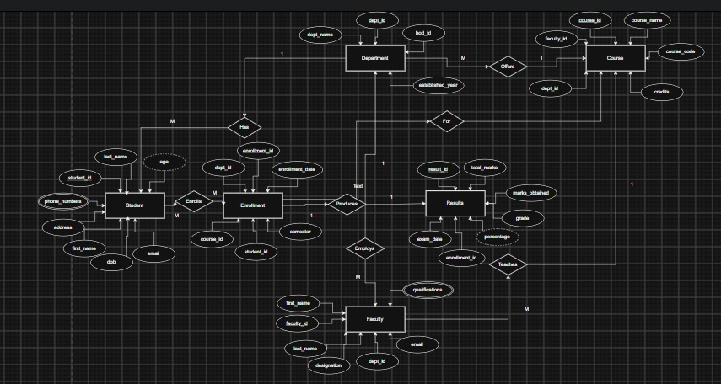

6.4 Relationships & Cardinality
Entity 1 | Relationship | Entity 2 | Cardinality (1:1 / 1:N / M:N)
STUDENT | belongs | DEPARTMENT | M:1
FACULTY | belongs | DEPARTMENT | M:1
COURSE | offered | DEPARTMENT | M:1
COURSE | handled | FACULTY | M:1
STUDENT | enrolls | COURSE | M:N
ENROLLMENT |  | RESULTS | 1:1

6.5 Relational Database Schema
List every table, its columns, data types, and identify PK/FK columns.
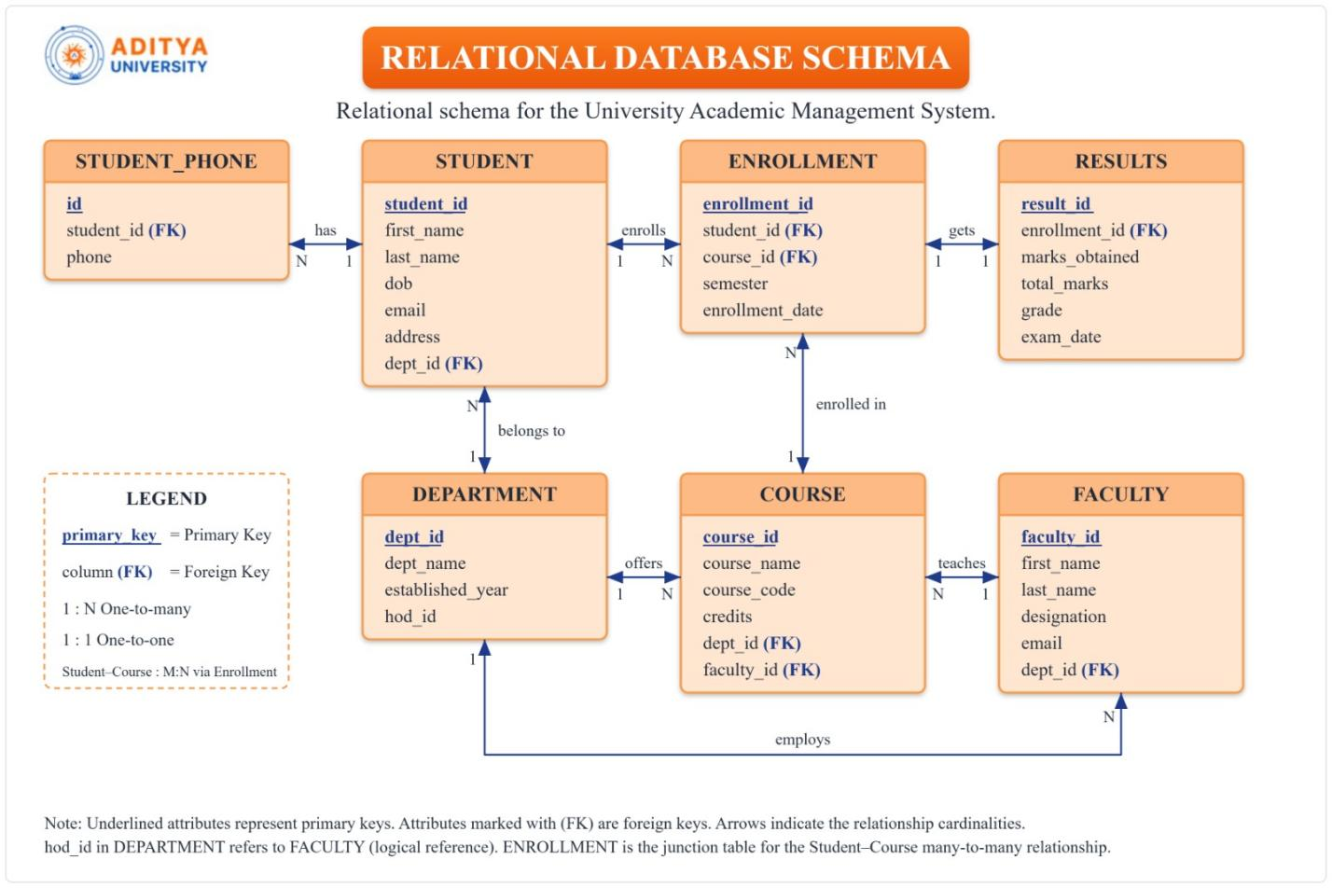

6.6 Normalization
Explain how redundancy and update anomalies were reduced. Show the normalization process up to 3NF where applicable.
UNF → 1NF → 2NF → 3NF

1NF: All attributes are atomic; multi-valued phone numbers moved to Student_Phone table.
2NF: No partial dependencies — all non-key attributes depend on the full PK.
3NF: No transitive dependencies — grade is determined by marks_obtained, but stored as a convenience; percentage is derived (computed view), not stored redundantly

7. DATABASE IMPLEMENTATION

7.1 DDL — Database and Table Creation
Paste CREATE DATABASE / CREATE TABLE statements and include constraints such as NOT NULL, UNIQUE, CHECK, DEFAULT, PRIMARY KEY, and FOREIGN KEY.
CREATE TABLE Department (
dept_id INT PRIMARY KEY AUTO_INCREMENT,
dept_name VARCHAR(100) NOT NULL UNIQUE,
established_year YEAR,
hod_id INT
);
CREATE TABLE Faculty (
faculty_id INT PRIMARY KEY AUTO_INCREMENT,
first_name VARCHAR(50) NOT NULL,
last_name VARCHAR(50) NOT NULL,
designation VARCHAR(50),
email VARCHAR(100) UNIQUE NOT NULL,
dept_id INT,
FOREIGN KEY (dept_id) REFERENCES Department(dept_id)
);

CREATE TABLE Student (
student_id INT PRIMARY KEY AUTO_INCREMENT,
first_name VARCHAR(50) NOT NULL,
last_name VARCHAR(50) NOT NULL,
dob DATE,
email VARCHAR(100) UNIQUE NOT NULL,
address TEXT,
dept_id INT,
FOREIGN KEY (dept_id) REFERENCES Department(dept_id)
);
CREATE TABLE Student_Phone (
id INT PRIMARY KEY AUTO_INCREMENT,
student_id INT NOT NULL,
phone VARCHAR(15),
FOREIGN KEY (student_id) REFERENCES Student(student_id)
);
CREATE TABLE Course (
course_id INT PRIMARY KEY AUTO_INCREMENT,
course_name VARCHAR(100) NOT NULL,
course_code VARCHAR(20) UNIQUE NOT NULL,
credits INT CHECK (credits BETWEEN 1 AND 6),
dept_id INT,
faculty_id INT,
FOREIGN KEY (dept_id) REFERENCES Department(dept_id),
FOREIGN KEY (faculty_id) REFERENCES Faculty(faculty_id)
);
CREATE TABLE Enrollment (
enrollment_id INT PRIMARY KEY AUTO_INCREMENT,
student_id INT NOT NULL,
course_id INT NOT NULL,
semester VARCHAR(20),
enrollment_date DATE,
UNIQUE (student_id, course_id, semester),
FOREIGN KEY (student_id) REFERENCES Student(student_id),
FOREIGN KEY (course_id) REFERENCES Course(course_id)
);
CREATE TABLE Results (
result_id INT PRIMARY KEY AUTO_INCREMENT,
enrollment_id INT UNIQUE NOT NULL,
marks_obtained DECIMAL(5,2) CHECK (marks_obtained >= 0),
total_marks DECIMAL(5,2) DEFAULT 100,
grade CHAR(2),
exam_date DATE,
FOREIGN KEY (enrollment_id) REFERENCES Enrollment(enrollment_id)
);

7.2 Sample Data — DML
Insert sufficient sample data into all tables. Include INSERT, UPDATE, and DELETE examples where applicable.
Table | No. of Records | Sample Data / Screenshot Reference
STUDENT | 10 | 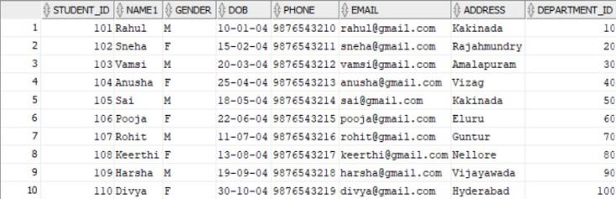
DEPARTMENT | 10 | 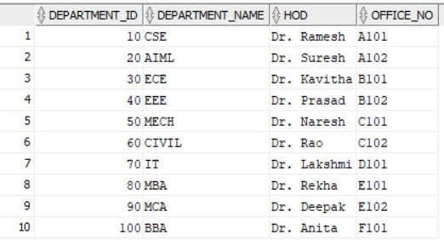
COURSE | 10 | 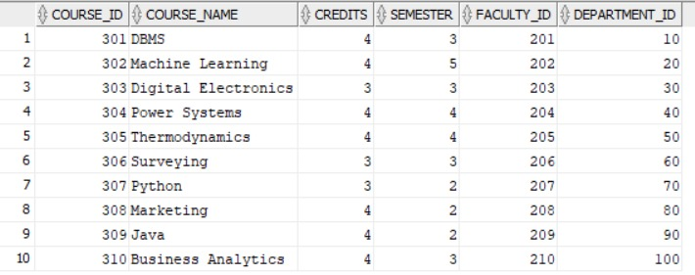
FACULTY | 10 | 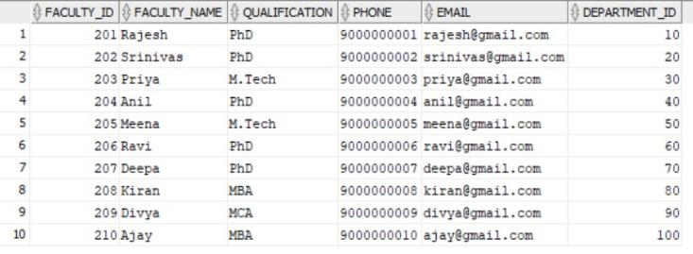
ENROLLMENT | 10 | 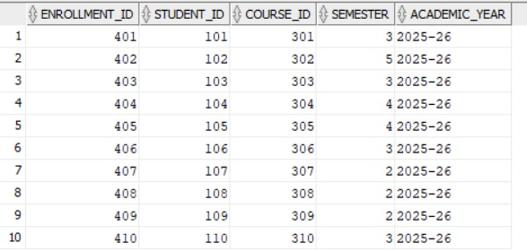
RESULTS | 10 | 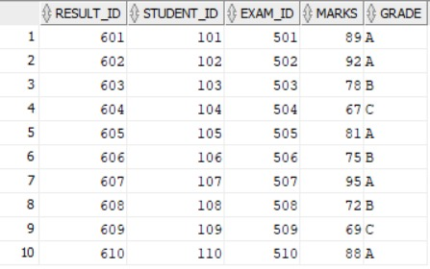

7.3 Constraints & Data Integrity
List the constraints and validations applied to keep the data accurate and consistent (no duplicate IDs, valid values, referential integrity).
Constraint / Validation | Applied On | Purpose
PRIMARY KEY | All Tables (e.g., Student_ID) | Ensures no duplicate records exist for core entities
UNIQUE | Department_Name, Email, Phone | Prevents duplication of sensitive/identifying information
FOREIGN KEY | e.g., Department_ID in Student | Maintains referential integrity, preventing orphan records.
CHECK | Gender IN ('M', 'F') | Ensures only valid categorical data is inserted.
CHECK | Marks BETWEEN 0 AND 100 | Prevents invalid exam scores from being recorded.
DEFAULT | Maximum_Marks DEFAULT 100 | Automatically populates standard exam criteria.
NOT NULL | Core attributes (e.g., Name, HOD) | Ensures mandatory fields are never left blank.

7.4 SQL Operations & Queries
Include representative examples of DDL, DML, DQL, CRUD, Joins, Aggregate Functions, GROUP BY / HAVING, Subqueries, Views, and other relevant queries.
S.No | Operation / Query | Purpose | SQL Query / Screenshot Ref.
1. | SELECT (DQL) | Fetch all students in the CSE department. | SELECT Name, Email FROM Student WHERE Department_ID = 10;
2. | JOIN | View Student Names and their respective Department Names. | SELECT s.Name, d.Department_Name FROM Student s JOIN Department d ON s.Department_ID = d.Department_ID;
3. | GROUP BY | Count the number of courses offered by each department. | SELECT Department_ID, COUNT(Course_ID) FROM Course GROUP BY Department_ID;
4. | AGGREGATE | Find the maximum marks obtained in exam 501. | SELECT MAX(Marks) FROM Result WHERE Exam_ID = 501;
5. | UPDATE (DML) | Update a faculty member's qualification. | UPDATE Faculty SET Qualification = 'PhD' WHERE Faculty_ID = 217;
6. | DELETE (DML) | Remove a specific alternate phone record. | DELETE FROM Student_Phone WHERE ID = 740;
7. | Basic Subquery | Find the names of all faculty members who belong to the 'CSE' department. | SELECT Faculty_Name FROM Faculty WHERE Department_ID = ( SELECT Department_ID FROM Department WHERE Department_Name = 'CSE' );
8. | Student Results View (Complex Join) | Create a virtual table that simplifies querying a student's performance by joining the Student, Result, Exam, and Course tables, hiding the complex joins from the end user. | CREATE VIEW Student_Results_View AS SELECT s.Name AS Student_Name, c.Course_Name, e.Exam_Type, r.Marks, r.Grade FROM Student s JOIN Result r ON s.Student_ID = r.Student_ID JOIN Exam e ON r.Exam_ID = e.Exam_ID JOIN Course c ON e.Course_ID = c.Course_ID;  SELECT * FROM Student_Results_View WHERE Grade = 'A';

7.5 Sample Outputs / Screenshots
Paste important execution screenshots with a short caption. Screenshots should clearly show the query and its output.
Figure 1: Find the names of all faculty members who belong to the 'CSE' department.
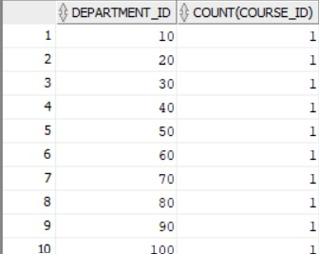
Figure 2: student data table
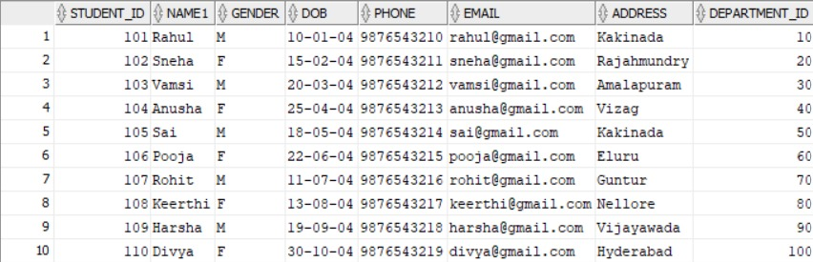
Figure 3: count faculties qualifications
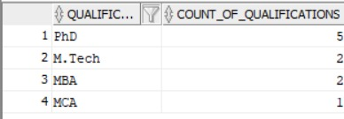

8. MODULES & FUNCTIONALITIES
Explain the major modules/features of the system and what each module does.
S.No | Module Name | Functionality
1. | Administration & Dept Module | Manages high-level structures (Department). Sets up foundational data like Department IDs, Names, and HODs.
2. | Faculty Management Module | Tracks teaching staff (Faculty), mapping them to departments and validating contact/email information.
3. | Student & Enrollment Module | Handles admissions, demographic data (Student), multiple contact numbers (Student_Phone), and course registrations (Enrollment).
4. | Academic & Curriculum Module | Organizes the curriculum (Course), allocating specific credits, semesters, and assigning responsible faculty members.
5. | Examination & Results Module | Schedules assessments (Exam) and securely records grades and marks (Result) tied to specific students and exams.

9. GITHUB REPOSITORY & TEAM RESPONSIBILITIES
Provide the repository link and clearly mention each team member's contribution.
Repository Link: https://github.com/mohithnaik112-ctrl/university-academic-management
Student Name | Roll Number | Role / Responsibility | Contribution Status
K.BALA ADITYA | 25B11AI581 | ER DAIGRAM,ENTITIES & ATTRIBUTES,RELATION SCHEMA | COMPLETED
M.MOHITH NAIK | 25B11AI765 | DATABASE CREATION, TABLES,PRIMARY KEY,FORGIEN KEY,CONSTRIANTS | COMPLETED
G.DILEEP | 25B11AI361 | DDL/DML/DQL,CRUD QUERIES,DOCUMENTATION | COMPLETED

10. ENHANCEMENTS & FUTURE IMPROVEMENTS
The current database establishes a solid foundation for academic management. Future enhancements to scale the system include:
● Authentication and Authorization: Introducing user roles (Admin, Faculty,Student) with encrypted passwords and login logs.
● Web/Mobile Interface: Connecting the DBMS to a front-end framework for seamless GUI interactions.
● Timetable Management: Creating a scheduling module to manage classroom allocations and lecture times.
● Automated Reports & Dashboard: Integrating views for generating real-time transcripts and performance analytics.
● Backup and Recovery & Improved Security: Implementing scheduled SQL dumps and advanced role-based access control (RBAC).

11. CONCLUSION
The University Academic Management System project successfully transformed standard academic operations into a streamlined, highly structured relational database. By identifying key entities—Department, Faculty, Student, Course, Exam, and Results—and mapping their intricate relationships, the system eliminated data redundancy through strict normalization up to the 3rd Normal Form (3NF). The extensive use of primary keys, foreign keys, and check constraints ensures robust data integrity, preventing scenarios such as invalid grades, duplicate contacts, or unassigned courses. Ultimately, this database effectively satisfies the core objectives, providing a scalable and reliable data backbone for university administration.

12. REFERENCES
List textbooks, articles, documentation, websites, or other resources referred to during the project.
- Elmasri, R., & Navathe, S. B. (2015). Fundamentals of Database Systems (7th ed.). Pearson.
- Silberschatz, A., Korth, H. F., & Sudarshan, S. (2019). Database System Concepts (7th ed.). McGraw-Hill Education.
- Aditya University, Department of AI & ML, DBMS Course Curriculum & Capstone Project Guidelines, Academic Year 2025–2026.

APPENDIX

A. Complete SQL Script
CREATE TABLE Department (
Department_ID INTEGER PRIMARY KEY,
Department_Name VARCHAR(50) NOT NULL UNIQUE,
HOD VARCHAR(50) NOT NULL,
Office_No VARCHAR(10) NOT NULL
);

INSERT INTO Department VALUES
(10, 'CSE', 'Dr. Ramesh', 'A101'),
(20, 'AIML', 'Dr. Suresh', 'A102'),
(30, 'ECE', 'Dr. Kavitha', 'B101'),
(40, 'EEE', 'Dr. Prasad', 'B102'),
(50, 'MECH', 'Dr. Naresh', 'C101'),
(60, 'CIVIL', 'Dr. Rao', 'C102'),
(70, 'IT', 'Dr. Lakshmi', 'D101'),
(80, 'MBA', 'Dr. Rekha', 'E101'),
(90, 'MCA', 'Dr. Deepak', 'E102'),
(100, 'BBA', 'Dr. Anita', 'F101');

CREATE TABLE Faculty (
Faculty_ID INTEGER PRIMARY KEY,
Faculty_Name VARCHAR(50) NOT NULL,
Qualification VARCHAR(30),
Phone VARCHAR(10) UNIQUE,
Email VARCHAR(60) UNIQUE,
Department_ID INTEGER NOT NULL,
CONSTRAINT FK_Faculty_Department
FOREIGN KEY (Department_ID) REFERENCES Department(Department_ID)
);

INSERT INTO Faculty VALUES
(201, 'Rajesh', 'PhD', '9000000001', 'rajesh@gmail.com', 10),
(202, 'Srinivas', 'PhD', '9000000002', 'srinivas@gmail.com', 10),
(203, 'Priya', 'M.Tech', '9000000003', 'priya@gmail.com', 20),
(204, 'Anil', 'PhD', '9000000004', 'anil@gmail.com', 20),
(205, 'Meena', 'M.Tech', '9000000005', 'meena@gmail.com', 30),
(206, 'Ravi', 'PhD', '9000000006', 'ravi@gmail.com', 30),
(207, 'Deepa', 'PhD', '9000000007', 'deepa@gmail.com', 40),
(208, 'Kiran', 'M.Tech', '9000000008', 'kiran@gmail.com', 40),
(209, 'Divya', 'M.Tech', '9000000009', 'divya@gmail.com', 50),
(210, 'Ajay', 'PhD', '9000000010', 'ajay@gmail.com', 50),
(211, 'Lakshmi', 'PhD', '9000000011', 'lakshmi@gmail.com', 60),
(212, 'Mohan', 'M.Tech', '9000000012', 'mohan@gmail.com', 60),
(213, 'Sita', 'PhD', '9000000013', 'sita@gmail.com', 70),
(214, 'Vijay', 'M.Tech', '9000000014', 'vijay@gmail.com', 70),
(215, 'Rekha', 'MBA', '9000000015', 'rekha@gmail.com', 80),
(216, 'Arun', 'PhD', '9000000016', 'arun@gmail.com', 80),
(217, 'Deepak', 'MCA', '9000000017', 'deepak@gmail.com', 90),
(218, 'Kavya', 'MCA', '9000000018', 'kavya@gmail.com', 90),
(219, 'Anita', 'MBA', '9000000019', 'anita@gmail.com', 100),
(220, 'Manoj', 'MBA', '9000000020', 'manoj@gmail.com', 100);

CREATE TABLE Student (
Student_ID INTEGER PRIMARY KEY,
Name VARCHAR(50) NOT NULL,
Gender CHAR(1),
DOB DATE,
Email VARCHAR(60) UNIQUE,
Address VARCHAR(100),
Department_ID INTEGER NOT NULL,
CONSTRAINT CHK_Student_Gender CHECK (Gender IN ('M', 'F')),
CONSTRAINT FK_Student_Department
FOREIGN KEY (Department_ID) REFERENCES Department(Department_ID)
);

INSERT INTO Student VALUES
(101, 'Rahul', 'M', '2004-01-10', 'rahul@gmail.com', 'Kakinada, Andhra Pradesh', 10),
(102, 'Sneha', 'F', '2004-02-15', 'sneha@gmail.com', 'Rajahmundry, Andhra Pradesh', 20),
(103, 'Vamsi', 'M', '2004-03-20', 'vamsi@gmail.com', 'Amalapuram, Andhra Pradesh', 30),
(104, 'Anusha', 'F', '2004-04-25', 'anusha@gmail.com', 'Visakhapatnam, Andhra Pradesh', 40),
(105, 'Sai', 'M', '2004-05-18', 'sai@gmail.com', 'Kakinada, Andhra Pradesh', 50),
(106, 'Pooja', 'F', '2004-06-22', 'pooja@gmail.com', 'Eluru, Andhra Pradesh', 60),
(107, 'Rohit', 'M', '2004-07-11', 'rohit@gmail.com', 'Guntur, Andhra Pradesh', 70),
(108, 'Keerthi', 'F', '2004-08-13', 'keerthi@gmail.com', 'Nellore, Andhra Pradesh', 80),
(109, 'Harsha', 'M', '2004-09-19', 'harsha@gmail.com', 'Vijayawada, Andhra Pradesh', 90),
(110, 'Divya', 'F', '2004-10-30', 'divya@gmail.com', 'Tirupati, Andhra Pradesh', 100),
(111, 'Arjun', 'M', '2004-01-21', 'arjun@gmail.com', 'Ongole, Andhra Pradesh', 10),
(112, 'Manasa', 'F', '2004-02-26', 'manasa@gmail.com', 'Chittoor, Andhra Pradesh', 20),
(113, 'Kiran', 'M', '2004-03-14', 'kiran.student@gmail.com', 'Srikakulam, Andhra Pradesh', 30),
(114, 'Lavanya', 'F', '2004-04-09', 'lavanya@gmail.com', 'Anantapur, Andhra Pradesh', 40),
(115, 'Naveen', 'M', '2004-05-27', 'naveen@gmail.com', 'Kadapa, Andhra Pradesh', 50),
(116, 'Sravani', 'F', '2004-06-16', 'sravani@gmail.com', 'Machilipatnam, Andhra Pradesh', 60),
(117, 'Teja', 'M', '2004-07-23', 'teja@gmail.com', 'Tenali, Andhra Pradesh', 70),
(118, 'Bhavya', 'F', '2004-08-05', 'bhavya@gmail.com', 'Vizianagaram, Andhra Pradesh', 80),
(119, 'Charan', 'M', '2004-09-28', 'charan@gmail.com', 'Proddatur, Andhra Pradesh', 90),
(120, 'Aishwarya', 'F', '2004-10-12', 'aishwarya@gmail.com', 'Bhimavaram, Andhra Pradesh', 100);

-- Phone numbers are stored separately so each student can have alternate numbers.
-- Values use India's +91 country code followed by ten digits.
CREATE TABLE Student_Phone (
ID INTEGER PRIMARY KEY,
Student_ID INTEGER NOT NULL,
Phone VARCHAR(13) NOT NULL,
Phone_Type VARCHAR(10) NOT NULL,
CONSTRAINT FK_Student_Phone_Student
FOREIGN KEY (Student_ID) REFERENCES Student(Student_ID),
CONSTRAINT CHK_Student_Phone_Type CHECK (Phone_Type IN ('Primary', 'Alternate'))
);

INSERT INTO Student_Phone VALUES
(701, 101, '+919876540001', 'Primary'), (702, 101, '+919876540002', 'Alternate'),
(703, 102, '+919876540003', 'Primary'), (704, 102, '+919876540004', 'Alternate'),
(705, 103, '+919876540005', 'Primary'), (706, 103, '+919876540006', 'Alternate'),
(707, 104, '+919876540007', 'Primary'), (708, 104, '+919876540008', 'Alternate'),
(709, 105, '+919876540009', 'Primary'), (710, 105, '+919876540010', 'Alternate'),
(711, 106, '+919876540011', 'Primary'), (712, 106, '+919876540012', 'Alternate'),
(713, 107, '+919876540013', 'Primary'), (714, 107, '+919876540014', 'Alternate'),
(715, 108, '+919876540015', 'Primary'), (716, 108, '+919876540016', 'Alternate'),
(717, 109, '+919876540017', 'Primary'), (718, 109, '+919876540018', 'Alternate'),
(719, 110, '+919876540019', 'Primary'), (720, 110, '+919876540020', 'Alternate'),
(721, 111, '+919876540021', 'Primary'), (722, 111, '+919876540022', 'Alternate'),
(723, 112, '+919876540023', 'Primary'), (724, 112, '+919876540024', 'Alternate'),
(725, 113, '+919876540025', 'Primary'), (726, 113, '+919876540026', 'Alternate'),
(727, 114, '+919876540027', 'Primary'), (728, 114, '+919876540028', 'Alternate'),
(729, 115, '+919876540029', 'Primary'), (730, 115, '+919876540030', 'Alternate'),
(731, 116, '+919876540031', 'Primary'), (732, 116, '+919876540032', 'Alternate'),
(733, 117, '+919876540033', 'Primary'), (734, 117, '+919876540034', 'Alternate'),
(735, 118, '+919876540035', 'Primary'), (736, 118, '+919876540036', 'Alternate'),
(737, 119, '+919876540037', 'Primary'), (738, 119, '+919876540038', 'Alternate'),
(739, 120, '+919876540039', 'Primary'), (740, 120, '+919876540040', 'Alternate');

CREATE TABLE Course (
Course_ID INTEGER PRIMARY KEY,
Course_Name VARCHAR(60) NOT NULL,
Credits INTEGER CHECK (Credits BETWEEN 1 AND 5),
Semester INTEGER CHECK (Semester BETWEEN 1 AND 8),
Faculty_ID INTEGER NOT NULL,
Department_ID INTEGER NOT NULL,
CONSTRAINT FK_Course_Faculty
FOREIGN KEY (Faculty_ID) REFERENCES Faculty(Faculty_ID),
CONSTRAINT FK_Course_Department
FOREIGN KEY (Department_ID) REFERENCES Department(Department_ID)
);

INSERT INTO Course VALUES
(301, 'Database Management Systems', 4, 3, 201, 10),
(302, 'Machine Learning', 4, 5, 203, 20),
(303, 'Digital Electronics', 3, 3, 205, 30),
(304, 'Power Systems', 4, 4, 207, 40),
(305, 'Thermodynamics', 4, 4, 209, 50),
(306, 'Surveying', 3, 3, 211, 60),
(307, 'Python Programming', 3, 2, 213, 70),
(308, 'Marketing', 4, 2, 215, 80),
(309, 'Java Programming', 4, 2, 217, 90),
(310, 'Business Analytics', 4, 3, 219, 100),
(311, 'Data Structures', 4, 3, 202, 10),
(312, 'Artificial Intelligence', 4, 5, 204, 20),
(313, 'Communication Systems', 3, 4, 206, 30),
(314, 'Electrical Machines', 4, 5, 208, 40),
(315, 'Manufacturing Processes', 3, 3, 210, 50),
(316, 'Structural Engineering', 4, 5, 212, 60),
(317, 'Web Technologies', 3, 4, 214, 70),
(318, 'Financial Management', 4, 4, 216, 80),
(319, 'Software Engineering', 4, 5, 218, 90),
(320, 'Principles of Management', 3, 2, 220, 100);

CREATE TABLE Enrollment (
Enrollment_ID INTEGER PRIMARY KEY,
Student_ID INTEGER NOT NULL,
Course_ID INTEGER NOT NULL,
Semester INTEGER,
Academic_Year VARCHAR(10),
CONSTRAINT FK_Enroll_Student
FOREIGN KEY (Student_ID) REFERENCES Student(Student_ID),
CONSTRAINT FK_Enroll_Course
FOREIGN KEY (Course_ID) REFERENCES Course(Course_ID)
);

INSERT INTO Enrollment VALUES
(401, 101, 301, 3, '2025-26'), (402, 102, 302, 5, '2025-26'),
(403, 103, 303, 3, '2025-26'), (404, 104, 304, 4, '2025-26'),
(405, 105, 305, 4, '2025-26'), (406, 106, 306, 3, '2025-26'),
(407, 107, 307, 2, '2025-26'), (408, 108, 308, 2, '2025-26'),
(409, 109, 309, 2, '2025-26'), (410, 110, 310, 3, '2025-26'),
(411, 111, 311, 3, '2025-26'), (412, 112, 312, 5, '2025-26'),
(413, 113, 313, 4, '2025-26'), (414, 114, 314, 5, '2025-26'),
(415, 115, 315, 3, '2025-26'), (416, 116, 316, 5, '2025-26'),
(417, 117, 317, 4, '2025-26'), (418, 118, 318, 4, '2025-26'),
(419, 119, 319, 5, '2025-26'), (420, 120, 320, 2, '2025-26');

CREATE TABLE Exam (
Exam_ID INTEGER PRIMARY KEY,
Course_ID INTEGER NOT NULL,
Exam_Type VARCHAR(20),
Exam_Date DATE,
Maximum_Marks INTEGER DEFAULT 100,
CONSTRAINT FK_Exam_Course
FOREIGN KEY (Course_ID) REFERENCES Course(Course_ID)
);

INSERT INTO Exam (Exam_ID, Course_ID, Exam_Type, Exam_Date, Maximum_Marks) VALUES
(501, 301, 'Mid', '2026-02-10', 100), (502, 302, 'Mid', '2026-02-11', 100),
(503, 303, 'Mid', '2026-02-12', 100), (504, 304, 'Mid', '2026-02-13', 100),
(505, 305, 'Mid', '2026-02-14', 100), (506, 306, 'Mid', '2026-02-15', 100),
(507, 307, 'Mid', '2026-02-16', 100), (508, 308, 'Mid', '2026-02-17', 100),
(509, 309, 'Mid', '2026-02-18', 100), (510, 310, 'Mid', '2026-02-19', 100),
(511, 311, 'Mid', '2026-02-20', 100), (512, 312, 'Mid', '2026-02-21', 100),
(513, 313, 'Mid', '2026-02-22', 100), (514, 314, 'Mid', '2026-02-23', 100),
(515, 315, 'Mid', '2026-02-24', 100), (516, 316, 'Mid', '2026-02-25', 100),
(517, 317, 'Mid', '2026-02-26', 100), (518, 318, 'Mid', '2026-02-27', 100),
(519, 319, 'Mid', '2026-02-28', 100), (520, 320, 'Mid', '2026-03-01', 100);

CREATE TABLE Result (
Result_ID INTEGER PRIMARY KEY,
Student_ID INTEGER NOT NULL,
Exam_ID INTEGER NOT NULL,
Marks INTEGER CHECK (Marks BETWEEN 0 AND 100),
Grade CHAR(2),
CONSTRAINT FK_Result_Student
FOREIGN KEY (Student_ID) REFERENCES Student(Student_ID),
CONSTRAINT FK_Result_Exam
FOREIGN KEY (Exam_ID) REFERENCES Exam(Exam_ID)
);

INSERT INTO Result VALUES
(601, 101, 501, 89, 'A'), (602, 102, 502, 92, 'A'),
(603, 103, 503, 78, 'B'), (604, 104, 504, 67, 'C'),
(605, 105, 505, 81, 'A'), (606, 106, 506, 75, 'B'),
(607, 107, 507, 95, 'A'), (608, 108, 508, 72, 'B'),
(609, 109, 509, 69, 'C'), (610, 110, 510, 88, 'A'),
(611, 111, 511, 84, 'A'), (612, 112, 512, 91, 'A'),
(613, 113, 513, 76, 'B'), (614, 114, 514, 63, 'C'),
(615, 115, 515, 86, 'A'), (616, 116, 516, 79, 'B'),
(617, 117, 517, 94, 'A'), (618, 118, 518, 71, 'B'),
(619, 119, 519, 68, 'C'), (620, 120, 520, 90, 'A');

Additional Screenshots / Outputs

Student table:
Department Table:
Faculty Table:
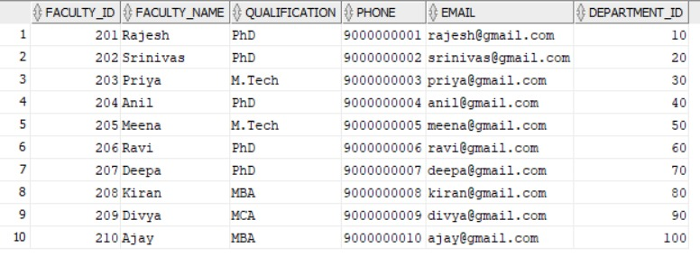
Course Table:
Enrollment Table:
Results Table:

